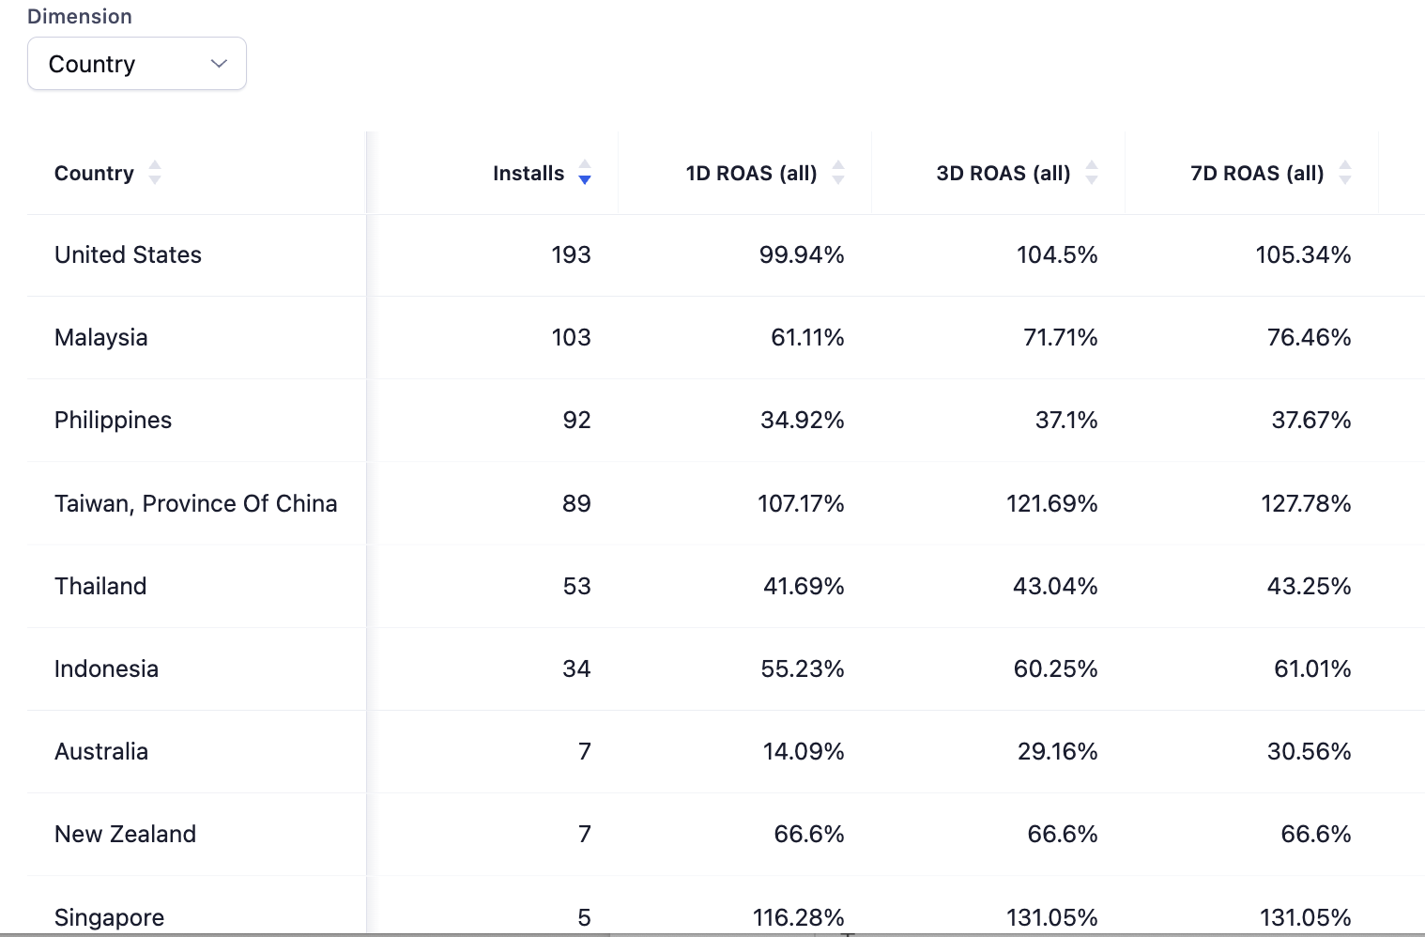

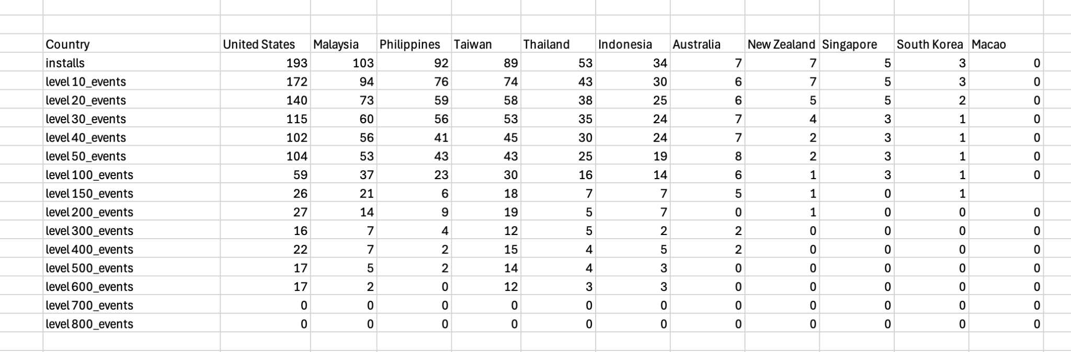

:bar_chart: Campaign Summary for Brain Tease (Last 7 Days)

* **Installs:** 586
* **Spend:** $495.90
* **Revenue:** $580.31 (Ads + IAP)
* **Blended ROAS:** **117% → Profitable** :white_check_mark:

:earth_africa: Country ROAS

* **Strong:** Taiwan (127.8%), Singapore (131%), USA (105%) → Scale these.
* **Weak:** Other regions underperforming → Cut/reduce spend.

:warning: Issues

* Big **drop-off after Level 100+** → Add daily rewards/streaks.
* **Low IAP share** of revenue → Optimize offers & pricing.

:white_check_mark: Action Plan

* **Scale** USA, Taiwan, Singapore.
* **Boost retention** with rewards & streaks.
* **Improve IAP monetization**.
* **Cut waste** in weak regions.